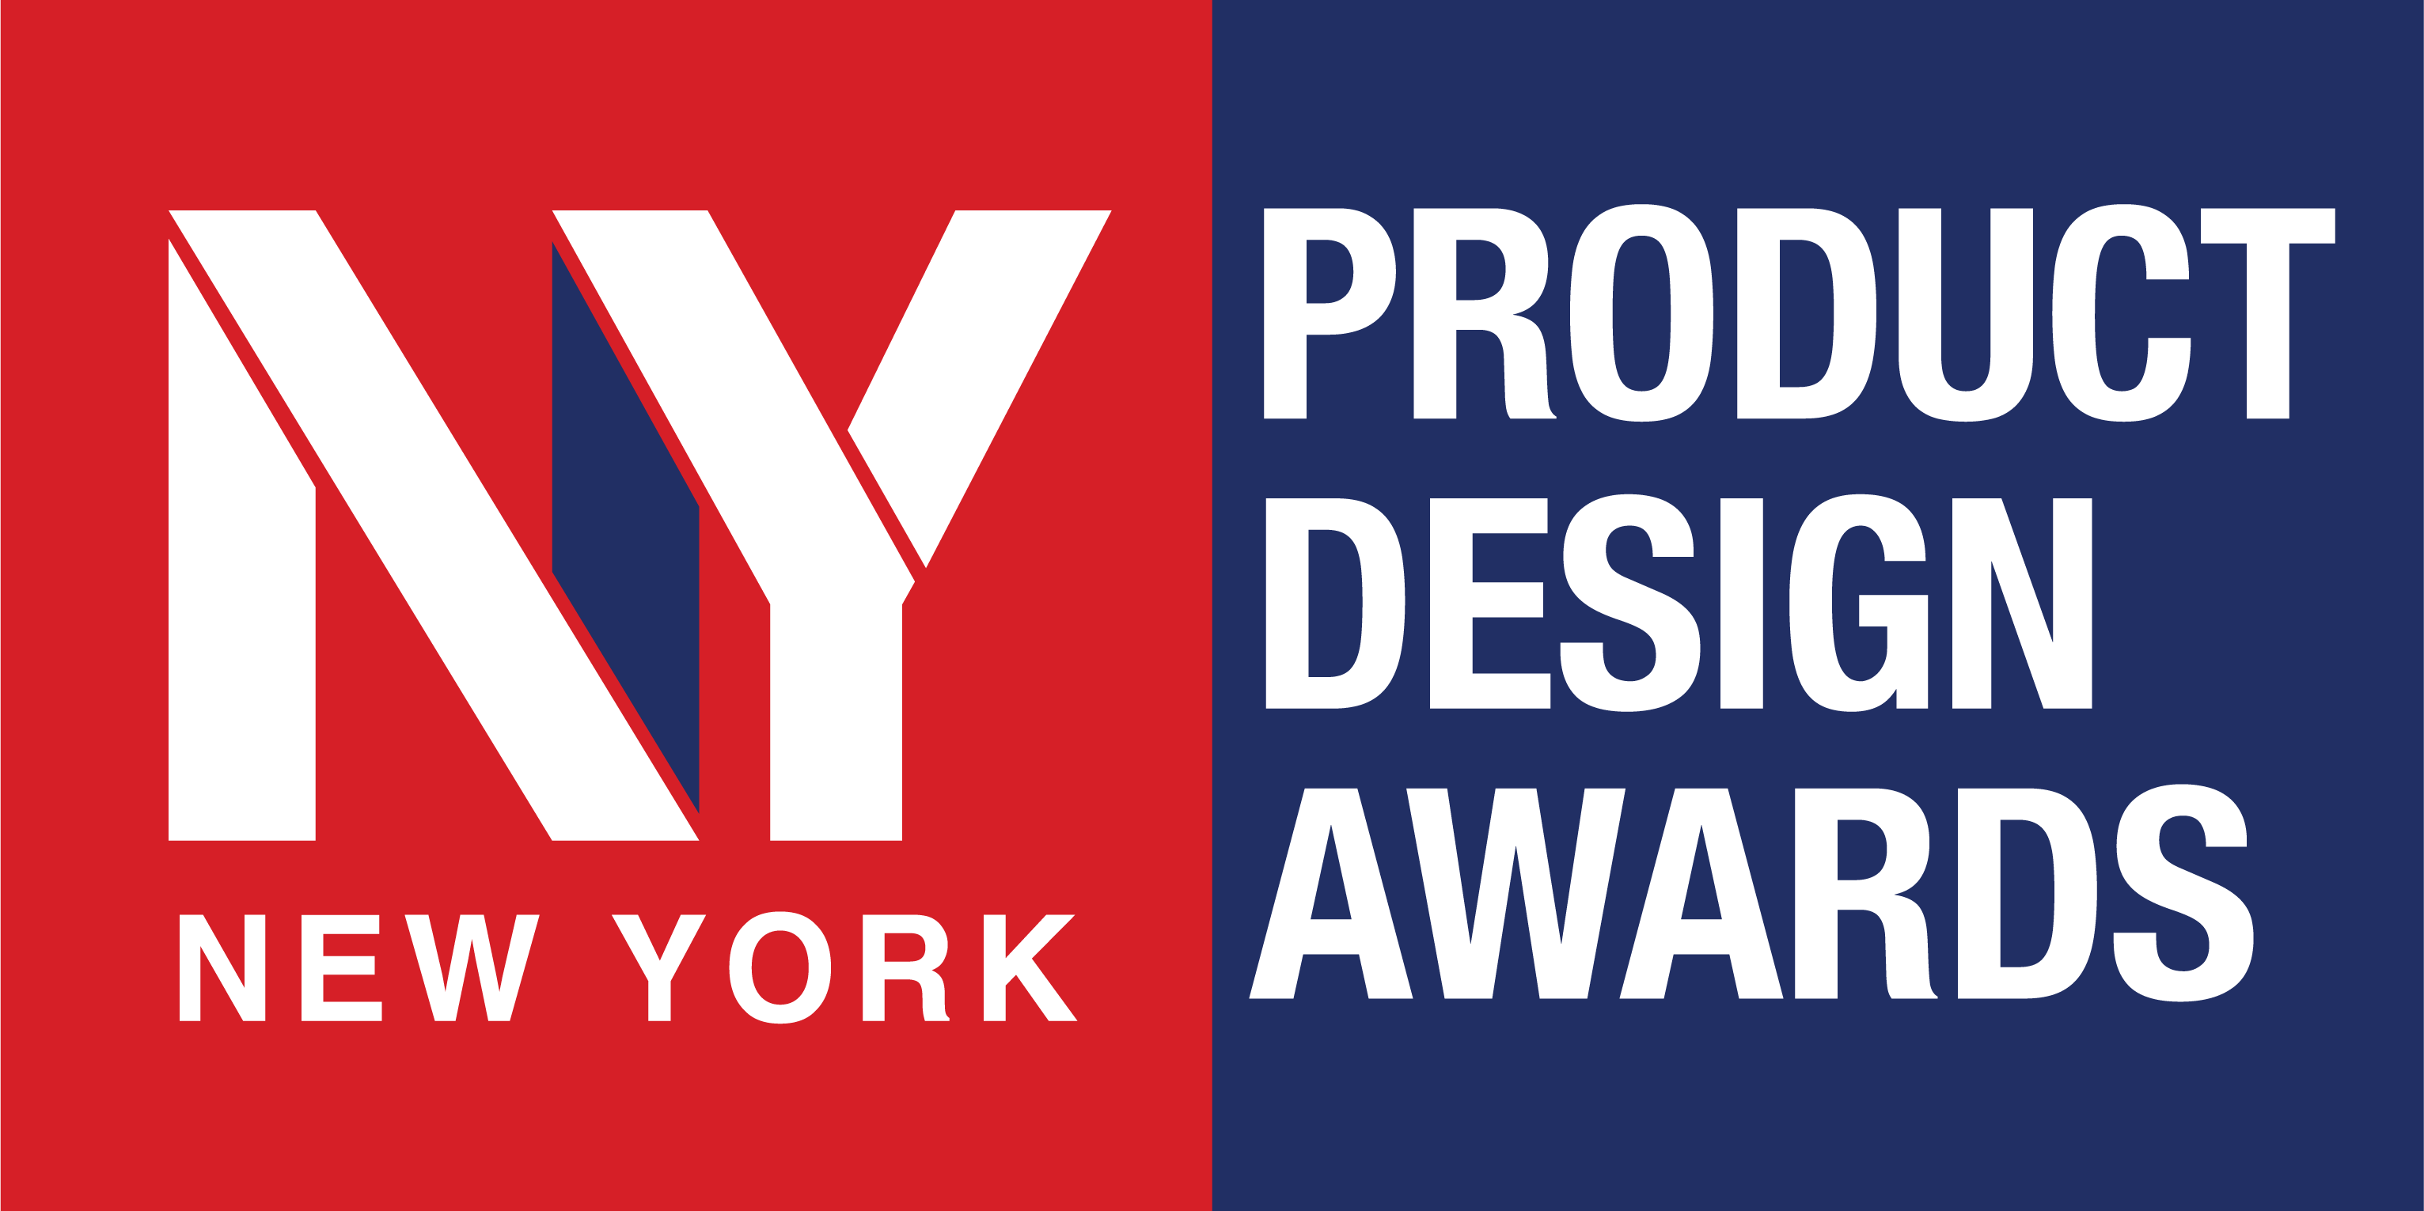

Contact:
(Contact Name)
(Title)
(Studio Name)
Email: (Email)
Phone: (Phone)
(Date)

FOR IMMEDIATE RELEASE

(Winner / Company Name) Wins (Product Design of the Year / Product Designer of the Year / Gold / Silver) at the 2026 NY Product Design Awards

(City, Country – Date) – (Winner / Company Name) has been recognized at the 2026 NY Product Design Awards Season 2, receiving the (Award Level) honor in (Category) for (Project / Product Name).

Organized by the International Awards Associate (IAA), the NY Product Design Awards is an international product design competition recognizing excellence in product design, innovation, functionality, and purposeful execution. This season attracted more than 1,100 submissions from around the world, bringing together established brands, design studios, manufacturers, independent designers, and emerging talent.

Award-Winning Product
(Winner / Company Name) received the (Award Level) distinction for (Project / Product Name), designed by (Designer / Design Team) for (Client / Brand, if applicable).

The winning design is distinguished by (briefly describe the key strength — e.g., innovative functionality, user-centered design, material innovation, sustainability, engineering, aesthetics). The recognition reflects the project's ability to combine original thinking, functionality, and accomplished execution in addressing its intended purpose.

Full details of the winning entry can be viewed here: (Insert Winner Page Link).

Winner's Statement
(Insert executive quote)
Example:
“We are honored to receive this recognition from the NY Product Design Awards,” said (Name, Title). “This achievement reflects our commitment to creating products that combine thoughtful design with meaningful value for the people who use them.”

International Recognition for Product Design Excellence
Season 2 entries were evaluated by 29 design professionals from 13 countries through a structured blind judging process, with submissions assessed on design merit, execution, functionality, and overall impact.

Winning an NY Product Design Award represents international recognition for product design excellence and innovation, placing recipients among designers and brands advancing contemporary product design.

For the complete list of 2026 NY Product Design Awards Season 2 winners, visit nydesignawards.com.

About (Winner / Company Name)
(Insert a concise 2–3 sentence company or designer profile, including expertise, market presence, notable products, or design philosophy.)
Website: (Insert Website)

About NY Product Design Awards
The NY Product Design Awards is an international competition recognizing excellence in product design and innovation. Open to designers, studios, brands, and manufacturers worldwide, the program honors products distinguished by originality, functionality, aesthetics, usability, and impact.

-###-

